2. Solutions: As per the question in the text book:

g1(n) = 2√logn

g2(n) = 2n

g4(n) = n4/3

g3(n) = n(log n)3

g5(n) = nlog n

g6(n) = 22n

g7(n) = 2n*n

The below table shows the actual growth rate of the function with three different inputs i.e., with n = 16,32 and 64. For a value which is very large in number has been market as “very large” in the above table.

|  |  |  |  |  |  |  |  |
| --- | --- | --- | --- | --- | --- | --- | --- |
| n | 2√logn | 2n | n4/3 | n(log n)3 | nlogn | 22n | 2n*n |
| 16 | 4 | 65536 | 39.39 | 1024 | 65536 | 4,294,967,296 | Very large |
| 32 | 4.47 | 4,294,967,296 | 97 | 4000 | 33,554,432‬ | Very large | Very large |
| 64 | 4.88 | Very large | 256 | 13824 | 68,719,476,736 | Very large | Very large |

As per the table above, we can arrange them in order as: **g1<g4<g3<g5<g2<g6<g7.**

Explanation: As we know that exponents grow faster so g2(n), g6(n) and g7(n) will be in the end of the order.

g1 grow slower than

2√log n = √log n log2  
log n (log n)3 = log n + 3logn

g3 is growing more slowly than g4. If we divide both sides by 3 and (log n)3 is against n1/3. Then (log n)3<n1/3*g4 will grow slower than g5, n4/3< n log n if n implies infinity. g5 develops slower than g2, n log n<2n as I said the g2 is exponential in the start and grows quicker.

g2 grows slower than g7, 2n < 2n2 * g7 grows slower than g6, 2n*n < 22n.

The below table is taken from the lecture slide which is used as a reference idea to take the individual growth rate of the function for relatively high input value i.e., n and arrange the functions in ascending order as per their growth rate.

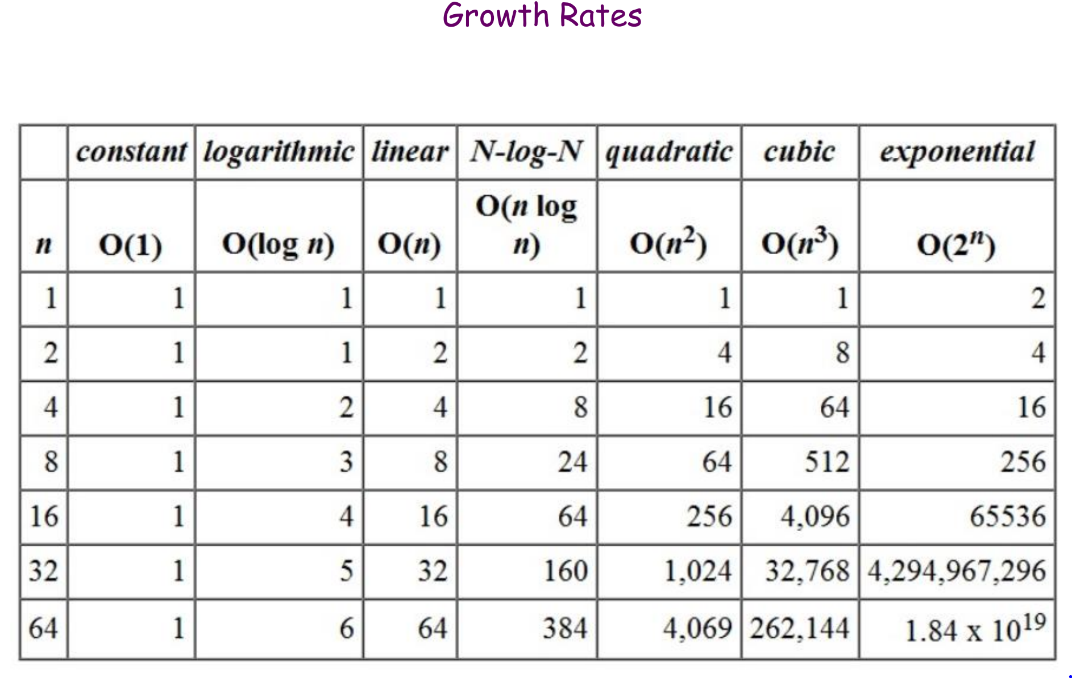

**Note:** In the Kleinberg and Tardos textbook, the function g4 is given before g3 and so the order of the function has been taken accordingly.